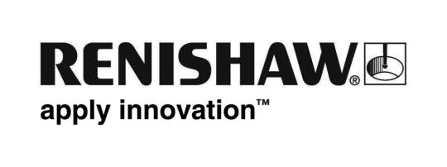
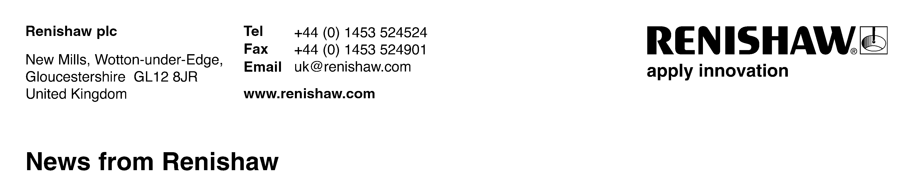
Enquiries: Chris Pockett, Group Marketing Services Manager (+44 1453 524133)

‘Irreplaceable’ Renishaw wins national business award
At the UK’s National Business Awards held on Tuesday 8th November at the Grosvenor House Hotel, London, global engineering company Renishaw was awarded the Grant Thornton Mid-Cap Business of the Year award for FTSE listed businesses and mutuals with a turnover of less than £500 million.

The award citation read by BBC presenter John Humphrys, who hosted the awards, said, “Renishaw is not only exporting British designed and British manufactured products to over 30 countries, but attracting more graduates into manufacturing at the same time. Developing innovative products that significantly advance its customers’ operating performance, the judges described Renishaw as ‘an irreplaceable business’.

In accepting the award, Ben Taylor, Renishaw’s Assistant Chief Executive, said, “We are delighted to win this award and it is recognition that UK manufacturing is alive and well. It not only makes a positive contribution to the economy, but it also offers very rewarding careers, and we believe that more young people should look at apprenticeship and graduate opportunities within the manufacturing sector.”

Scott Barnes, CEO, Grant Thornton said: "Renishaw is a great example of the UK's impressive mid-market businesses. Bucking recent economic trends with strong growth, impressive export statistics and providing jobs and training to the UK market, Renishaw, and indeed all the finalists, are the companies that we see driving our economy. Congratulations to the team at Renishaw for exemplifying great British business."

The award category is nomination only and Renishaw was shortlisted for the award along with nine other high performing UK companies including SuperGroup (manufacturer of Superdry clothing), Majestic Wine, Moneysupermarket, Rightmove and the Cineworld Group. The award is judged such that ‘The ultimate winner of this award will be held up as an example of excellent practice and an inspiration to all listed companies or mutuals in the mid-cap range, with judges considering past achievement, current performance and future potential.’

The awards were attended by over 1,100 top UK business leaders and entrepreneurs, with the welcome address delivered by The Chancellor of the Exchequer, Rt Hon George Osborne MP.
Ends

About the National Business Awards
Open to organisations of all sizes from all sectors across the UK, the National Business Awards in partnership with Orange is the UK’s most prestigious independent business recognition platform with its particular emphasis on excellence, innovation and ethical business. Now in its tenth year, the National Business Awards connects the nations’ professionals through its annual awards ceremony; year-round thought leadership and round table events; and is UBM Plc’s flagship awards programme. Visit www.nationalbusinessawards.co.uk for further information.

