18th November 2016
Caltech working to solve the world’s energy problems with the help of Renishaw’s inVia Raman microscope
Fossil fuels are the world’s main fuel source for transportation, heating and generating electricity. As a by-product, high levels of CO₂ are released into the atmosphere. With the drive for sustainable energy production, a method that generates easily-stored fuel from sunlight—and absorbs CO₂—is a very attractive proposition.
The California Institute of Technology (Caltech) is on a mission to find new and effective ways to produce solar fuels using only sunlight, water and carbon dioxide. A focus of this is investigating photocatalysis and light capture. Dr David A. Boyd is using Raman spectroscopy to accelerate the discovery and in-depth understanding of photocatalysts and photoactive materials for the solar-driven CO₂ reduction reactions.
Dr Boyd uses a Renishaw custom designed inVia Raman Microscope, installed at the Joint Centre for Artificial Photosynthesis (JCAP). JCAP is one of the Department of Energy’s Energy Innovation Hubs and is led by a team from Caltech. The High Throughput Experimentation (HTE) group aims to accelerate the identification of semiconductor materials, with appropriate band energetics, for efficient photoelectrocatalysis of solar fuel reactions. They use combinatorial materials synthesis and high-throughput electrochemistry to create and identify candidate materials. A novel example is the use of ink-jet printing to produce thousands of different combinations of metal oxide photocatalysts on a single 4” × 6” substrate, prior to electrochemical studies.
Dr Boyd said, “The inVia system is a natural fit to assist in the identification and characterisation of metal oxide catalysts. Given our sample sizes and the need to differentiate a number of possible material phases, we require large area mapping and advanced analysis capabilities. The Renishaw Empty Modelling tools have been especially invaluable; they have enabled us to derive basic spectra from the Raman imaging datasets, which could then be identified and matched to reference patterns from the literature and the RRUFF mineral database. This has allowed us to identify materials that are strong performers.”
Dr Boyd and his colleagues have recently published a paper on this work in the RSC Journal of Materials Chemistry A, ‘Solar Fuels Photoanodes Prepared by Inkjet Printing of Copper Vanadates.’ This paper^{[1]} describes the processing and characterisation of these exciting new materials that address the demanding requirements needed to perform the photoelectrocatalysis oxygen evolution reaction. A key element of this work is Raman imaging, with associated data processing and visualisation, which has enabled phase mapping of the array of compositions. This has led to the identification of promising photoanodes for solar fuel applications.
Please visit www.renishaw.com/materialsscience for further details on how Renishaw’s inVia confocal Raman microscope is being used in materials characterisation.

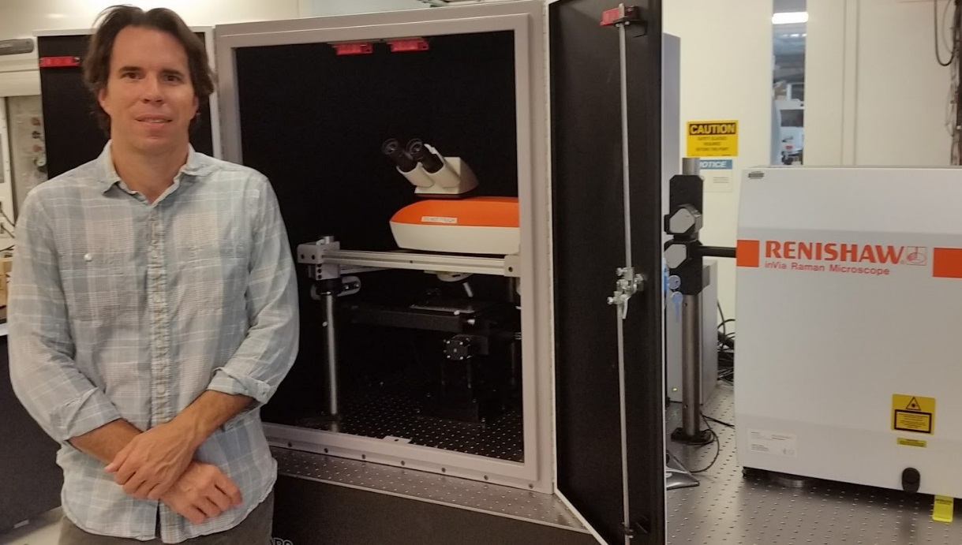
Image: Dr David Boyd of Caltech with his customised inVia. The system includes a free space microscope inside a Class 1 laser enclosure, enabling the routine analysis of large samples. The system uses direct optical coupling, rather than fibre optics, to ensure high optical efficiency and high spatial resolution.
Reference
¹ P. Newhouse, D.A. Boyd, A. Shinde, D. Guevarra, L. Zhou, E. Soedarmadji, G. Li, J. Neaton and J. Gregoire, J. Mater. Chem.A, 2016, DOI: 10.1039/C6TA01252C.
-Ends-

About Renishaw
Renishaw is one of the world's leading engineering and scientific technology companies, with expertise in precision measurement and healthcare. The company supplies products and services used in applications as diverse as jet engine and wind turbine manufacture, through to dentistry and brain surgery. It is also a world leader in the field of additive manufacturing (also referred to as 3D printing), where it is the only UK business that designs and makes industrial machines which ‘print' parts from metal powder.
The Renishaw Group currently has more than 70 offices in 35 countries, with over 4,000 employees, of which 2,700 people are employed within the UK. The majority of the company's R&D and manufacturing is carried out in the UK and for the year ended June 2016 Renishaw achieved sales of £436.6 million of which 95% was due to exports. The company's largest markets are the China, USA, Germany and Japan.
The Company's success has been recognised with numerous international awards, including eighteen Queen's Awards recognising achievements in technology, export and innovation. Renishaw received a Queen’s Award for Enterprise 2014, in the Innovations category, for the continuous development of the inVia confocal Raman microscope. For more information, visit www.renishaw.com

For further information
Please contact:
David Reece
Renishaw plc
New Mills
Wotton-under-Edge
Gloucestershire GL12 8JR UK
Tel: +44 1453 523968 (direct)
Tel: +44 1453 524524 (switchboard)
Fax: +44 1453 523901
Email: david.reece@renishaw.com
www.renishaw.com/raman

