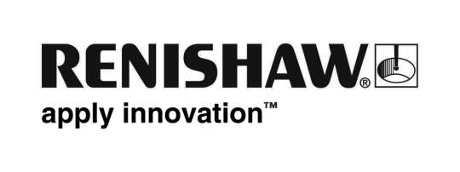
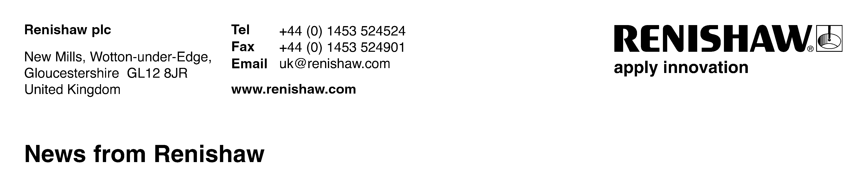
May 18th 2011 – for immediate release Further information: Chris Pockett, +44 1453 524133

Geometric Modelling Library and associated development services

Renishaw reveals a new library of geometric modelling functionality for application builders supported by a bespoke application development service.

Renishaw’s Geometric Modelling Library (GML) consists of more than 7,500 functions developed over recent years to resolve many complex geometry problems. The library is now available for trial. Typical usage is within industries such as biomedical, dental, industrial metrology, aerospace and automotive, by those with a need to solve and debug complex geometry problems.

Use of the library provides application developers with the reassurance that complex geometry manipulation is in the hands of tried-and-tested functions, leaving them to focus on their own value adding application development.

Bespoke development services
Renishaw is keen to help clients benefit from its extensive experience of applying this library to solve problems in a wide range of industries. The Company can provide a team of experts to provide advice and build capability for bespoke applications incorporating the GML library.

Rapid development environment
Having spent recent years extending the functional library to meet its own development requirements, Renishaw has created a true API which enables developers to embed the library within other applications, where it will work with the existing graphical user interface (GUI). The addition of extensive sample code and documentation, complete with a GUI, results in a comprehensive rapid development environment.

The library
At the heart of the GML is a suite of C++ classes and functions designed to support and facilitate the development of any application requiring complex geometry manipulation. To facilitate this, the GML provides:

The main modelling primitives, including:
- Random/ordered point clouds
- High density triangulations
- NURBS curve and surfaces

Extensive support functionality, including:
- Comprehensive container classes
- Core maths and geometry
- Surface construction and triangulation
- Registration and error analysis
- Complex surface fitting and modification
- CAD to part inspection
- Reverse engineering
- Multi-axis path-planning and machining

A visual development environment with a:
- Fully extendable API
- Fully extendable and customisable GUI

For further details about the GML software and the development services that Renishaw is providing, please visit www.renishaw.com/gml
Ends

